INTERNATIONAL FREESTYLE SKATING CHAMPIONSHIPS 2014
NOVEMBER 26TH TO 30TH

ACCOMMODATION
Located in the east, Costa Sands Resort (Downtown East) remains a popular choice holiday destination for guests looking for a quick getaway. The resort’s popularity has also grown in terms of new facilities and amenities added to offer guests a home away from home. Guests can enjoy a range of activities such as exploring the resort, having a BBQ cookout, swimming, enjoying fun time at Wild Wild Wet (bigger water park) or bowling. Alternatively, they can relax in the comfort of their air-conditioned rooms equipped with a television set, DVD player, free Wi-Fi access, and other amenities.

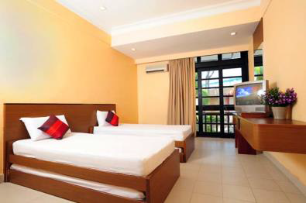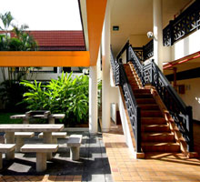

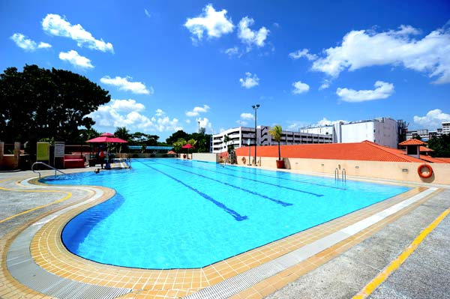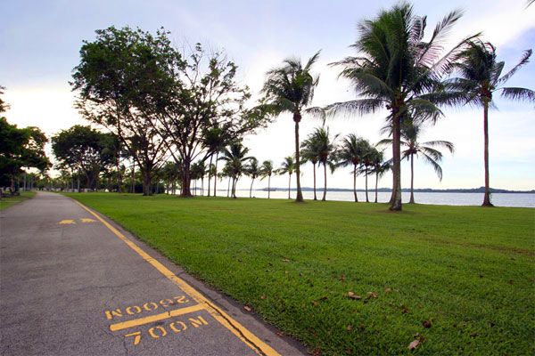

DELUXE ROOM
These comfortable rooms feature amenities including
- Full air-conditioning
- Bedding for maximum of 4 guests: 2 single beds with pull-out beds/ 4 single beds/ 2 queen bed (subject to availability)
- Attached bathroom
- Wardrobe
- Television set with DVD player
- Refrigerator
- Hot water flask
- Towels
- Free Wi-Fi access

ROOM TYPE
- TWIN : 165SGD per person per night
- QUAD : 90SGD per person per night

PRICE INCLUDES :
- Airport transfer
- 2 ways transportation from resort to competition venue
- Farewell party

ENQUIRY and RESERVATION
terence@rollersports.org.sg

CLOSING DATE
Please send and confirmed your reservation before or not latest than 30 Oct 2014

CANCELLATIONS
Cancellations after confirmation will be subjected to a minimum of 30% cancellation fee.
Cancellation fees up to 100% will be applied if cancel within 15 days of departure date

Regards
Shirley Tay

